**Performance Testing Hands-on**

**Business Case**: Performance Comparison of the Source and Target applications.

**Process**: Installation of the tool for performing the test. Here tool used is Apache JMeter. Performance Testing of source server and then target server. Analyse the results of the two tests.

**Main Tasks**

1. JMeter Setup
2. Test performance of source server
3. Test performance of target server
4. Compare results.
5. **JMeter Setup.**

Source Server Details

URL: <http://3.27.160.86/CollegeMgmt>

* 1. Go to the downloaded JMeter folder -> Double click /bin/jmter.bat (.sh in Mac). Command window will run. Do not close it. JMeter will start.

* 1. Download the script file from <https://github.com/SmithaVerity/PerformanceTesting.git>

1. **Test performance of source server.**
   1. In JMeter Click Open and select the College.jmx file from the downloaded folder.

* 1. Check host ip address in the Test Plan. (Source: 3.27.160.86)

* 1. In Thread Group, make Loop count as 1.

* 1. Give a file name (like results1.csv) and run the test by clicking the green start button.

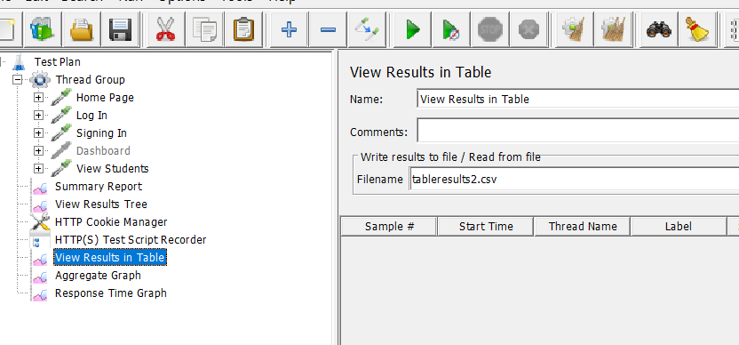

* 1. In Thread Group, make Users count as 10 and Loop count as 10 and try.

1. **Test performance of Target server.**
   1. Change host ip address in the Test Plan to your server ip.
   2. In Thread Group, make Users count as 10 and Change Loop count to 10.
   3. Change the filename like results2.csv.
   4. Run the test.
2. **Compare Results.**
   1. Compare the data in the csv files.